ACE Mission Control and Onboard Computer

Brief Manual and Reference for version 1.1

Contents

ACE Mission Control Quick Start Guide 2

Connecting to the Onboard Computer and Planning the Mission 2

Before Each Flight 3

During Flight 3

Failsafes 3

Advanced Onboard Computer Operations 4

Accessing Command Line with a Keyboard and Monitor 4

Accessing Command Line with PuTTY 4

Onboard Computer Command Line Reference 5

Accessing File Transfers with WinSCP 5

Retrieving Onboard Computer Logs 6

Onboard Computer Configuration Reference 6

# ACE Mission Control Quick Start Guide

## Connecting to the Onboard Computer and Planning the Mission

1. Under **Onboard Computer and Drone Connection** enter the IP address for the onboard computer, press Apply, and then toggle on **Connect to ACE Onboard Computer**.  
   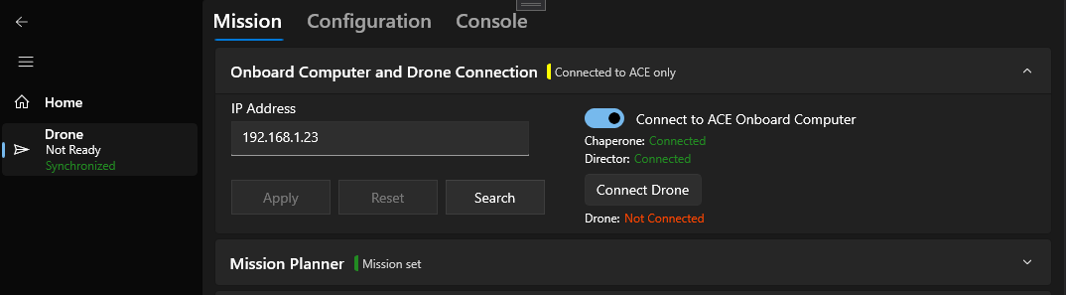
2. If the drone is on and not already connected, press **Connect Drone**.
3. In **UgCS**, prepare your treatment area and route. ACE uses both the **Area Scan Route** and the **Waypoint Route** to determine where to perform treatment.
4. Under **Mission Planner** you should see all of your **Area Scans** from UgCS. They will be updated from UgCS every few seconds. Enable the area you will be treating by checking the **Enabled** box.  
   *Note: If you are seeing the Area Scans from a different mission, you can press* ***Refresh UgCS Mission*** *to automatically select the mission with the most recent changes.*
5. In the **Waypoint Route** column, use the box to select to route that you will be uploading to the drone.
6. Make sure the start symbol is at the right point on the map. By default, it will start at the first entry into the treatment area. You can set the start to a specific waypoint by selecting the **Selected Waypoint treatment start mode**.  
   *Note: The map tool is provided by Microsoft and is known to freeze randomly. If your map freezes use the reload button on the top right.*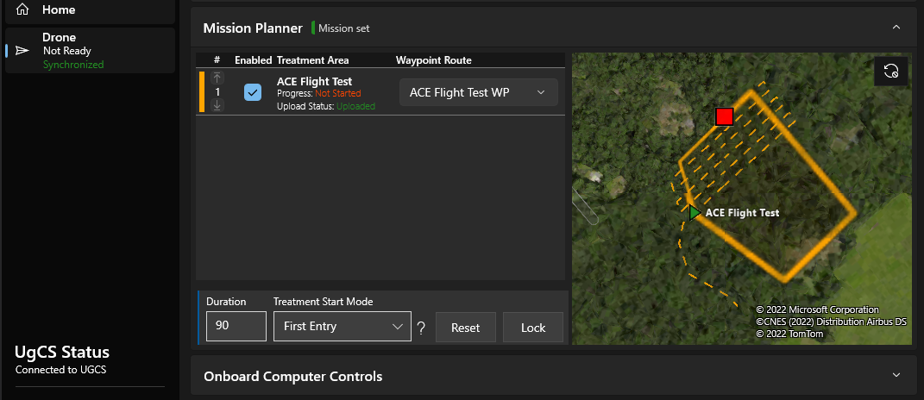

## Before Each Flight

You must check two things before every flight.

1. The drone status in the left panel reads: **Ready for Take-off** and **Synchronized**.
2. The start symbol  is in the correct location.

**If you do not verify these two things the payload may never activate or may activate in the wrong location.**

## During Flight

Under normal conditions, after the payload has exceeded the treatment duration ACE will initiate a return home. At this point you may take manual control of the drone.

Once the drone enters **Auto mode**, ACE will lock changes and switch the stage to **Enroute.** Changes can be unlocked from Mission Control or by putting the drone back in **Manual mode.**

### Failsafes

* If at any point during the flight the onboard computer detects something is not operating correctly it may initiate a return home early.
* If the onboard computer lost connection to the drone, it will not be able to initiate a return home. If the payload is driven by the onboard computer (M600 only) it will stop the payload in this situation.
* At any point the pilot can take control of the drone which will halt the mission. From here the mission can still resumed by re-entering **Auto mode,** or the drone can be brought back home.
* If the onboard computer is connected to Mission Control, you can use the **Restart Director** or **Force Stop Payload** *(M600 only)* functions under **Onboard Computer Controls** in response to unexpected behaviour.

# Advanced Onboard Computer Operations

## Accessing Command Line with a Keyboard and Monitor

By connected a USB keyboard and an external monitor to the onboard computer you can simply access the command line.

1. Connect the keyboard and monitor to the onboard computer then power it on. You should immediately see the onboard computer writing out information as it starts up.
2. After a few seconds, the onboard computer will prompt you to enter a username and then a password. The username is “**pi**”, and the password is “**gdgDRONE$**”. The password will be hidden as you type it.
3. After entering the password, you will have command line access.

## Accessing Command Line with PuTTY

Using the program “PuTTY” you can access the command line interface for the onboard computer without connecting any cables.

1. If it’s not already installed, download the latest version of PuTTY from here: <https://www.chiark.greenend.org.uk/~sgtatham/putty/latest.html>
2. Ensure the onboard computer is powered on and connected to the same WiFi network as your computer. If the onboard computer does not know any nearby WiFi network, you may create a WiFi hotspot named “**gdg-hotspot**” with the password “**gdg12345**”. The onboard computer will prioritize connecting to this network if it’s available.
3. Find the IP address of the onboard computer. This is four numbers separated by dots (ex. 192.168.1.20). If you have setup a WiFi hotspot, you may find the IP of the connected devices under the WiFi Hotspot Preferences on your phone. You may also try the Search function in ACE Mission Control or try logging into the wireless router from your web browser to find connected devices.
4. 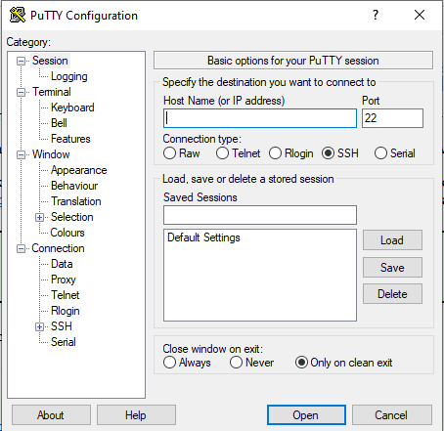In PuTTY, enter the IP address of the onboard computer and select Connection type **SSH**. Press Open.
5. If prompted to trust a certificate or security key, press Yes.
6. A command line window should open, prompting you to enter a username and then a password. The username is “**pi**”, and the password is “**gdgDRONE$**”. The password will be hidden as you type it.
7. After entering the password, you will have command line access.

## Onboard Computer Command Line Reference

When connected to the command line of the onboard computer you will have access to more advanced functions. This is a short list of options you have.

|  |  |
| --- | --- |
| Function | Command |
| Change system settings (ex. add a WiFi network or change locale settings) | *sudo raspi-config*  Select **Network Options** to add a WiFi network or change the name (hostname) of the onboard computer.  Select **Localization Options** to change the time zone, keyboard layout, or language. |
| Display IP address | *hostname -I* |
| See the name of the current WiFi network | *iwgetid -r* |
| Update ACE with the latest stable version | *~/update_ace.sh* |
| Update ACE with the latest development version | *~/update_ace_dev.sh* |
| Disable ACE auto-starting | *sudo systemctl disable ace.service* |
| Enable ACE auto-starting | *sudo systemctl enable ace.service* |
| Stop ACE manually | *~/stop_ace.sh* |
| Start ACE manually | *~/start_ace.sh* |

## Accessing File Transfers with WinSCP

1. If it’s not already installed, download the latest version of WinSCP from here: <https://winscp.net/eng/download.php>
2. Ensure the onboard computer is powered on and connected to the same WiFi network as your computer. If the onboard computer does not know any nearby WiFi network, you may create a WiFi hotspot named “**gdg-hotspot**” with the password “**gdg12345**”. The onboard computer will prioritize connecting to this network if it’s available.
3. Find the IP address of the onboard computer. This is four numbers separated by dots (ex. 192.168.1.20). If you have setup a WiFi hotspot, you may find the IP of the connected devices under the WiFi Hotspot Preferences on your phone. You may also try the Search function in ACE Mission Control or try logging into the wireless router from your web browser to find connected devices.
4. In WinSCP on the login window that opens, select file protocol **SFTP** enter the IP address, the username “**pi**”, and the password “**gdgDRONE$**”. Press Login.
5. 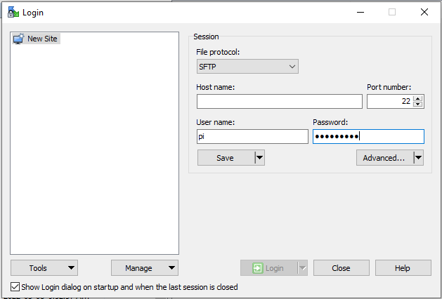If prompted to trust a certificate or security key, press Yes.
6. On the right side of the WinSCP window you will now see files that are on the onboard computer.

## Retrieving Onboard Computer Logs

The onboard computer will create one log file each day that may provide additional details on why something isn’t working.

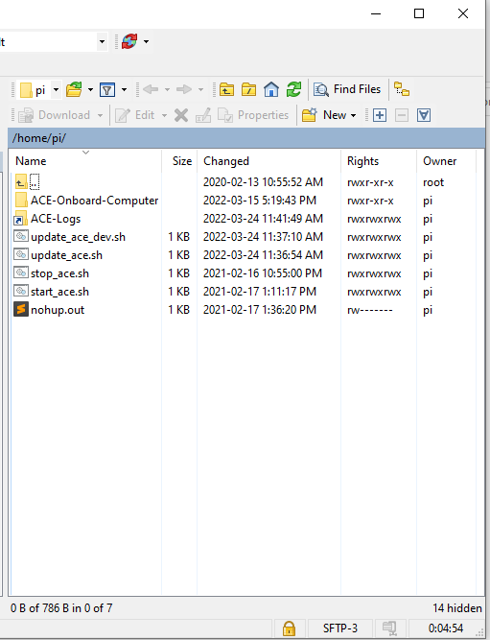To access the logs, follow the procedure for **Accessing File Transfers with WinSCP**. Once connected, open the **ACE-Logs** folder. From here you can drag or drop the files onto your computer.

The onboard computer does not have a battery to keep track of time when it’s not powered. If it is not connected to the internet there is no guarantee that it will have the correct time for the logs. In WinSCP sort by **Changed** to make sure you’re retrieving the most recent log file.

# Onboard Computer Configuration Reference

|  |  |  |  |
| --- | --- | --- | --- |
| Section | Option | Value Options | Description |
| Director | DRONE_TYPE*  *Default: M600* | M600  H20 | The type of drone being used. |
| HIGH_PRIORITY_UPDATE_HZ  *Default: 32* | Frequency (Hz) | How frequently ACE checks if new data has been received from the drone or if there have been any errors. |
| LOW_PRIORITY_UPDATE_HZ*  *Default: 5* | Frequency (Hz) | How frequently ACE handles commands that it has received and sends updates to Mission Control. |
| SQL_ENABLED*  *Default: True* | True/False | Enables sending the drone status to GDG’s ArcGIS server. |
| SQL_UPDATE_RATE  *Default: 3.0* | Seconds | How frequently the drone status is sent if SQL is enabled. |
| USE_HOLOGRAM_MODEM*  *Default: True* | True/False | Enables connecting to the internet over LTE using the Hologram modem (USB attachment). Only functions if the USB modem is attached. |
| Mission | ENTRY_EXIT_BUFFER**  *Default: 6.5* | Metres | How close the drone must pass to the start or stop coordinate for the EXECUTING mode to be activated.  If the drone passed the start point but did not begin treating, then this may need to be larger.  Once in EXECUTING mode the drone will start treating whenever it is in the treatment area. Make sure the buffer not so large that it could be passed accidentally! It should be at least 4 metres less than the swath and greater than 4 metres. |
| TREATMENT_EXECUTE_BUFFER**  *Default: 0.0* | Metres | The number of metres to expand the treatment area by on all sides, if desired.  If the payload is activating too late and deactivating too early, increasing this value could solve the problem. |
| ACCELERATION_START_SPEED  *Default: 1.0* | m/s2 | How fast the drone must accelerate in metres per second squared to trigger treatment again after stopping. This can be lowered if the function isn’t working. |
| HALT_TREATING_STOPPED_DURATION  *Default: 2.0* | Seconds | How long the drone can be very slow or stopped for, mid-treatment, before the mission is temporarily halted. This uses VELOCITY_STOPPED_SPEED to determine whether the drone is currently moving or stopped. |
| PAYLOAD_USES_PREACTIVATION**  *Default: True* | True/False | Specifies whether the payload has a separate motor which should spin-up before treating. |
| PAYLOAD_PREACTIVATE_METRES**  *Default: 10* | Metres | If the above is True, specifies how far away from the treatment area should the motor start spinning up. |
| PAYLOAD_TEST_DURATION  *Default: 5* | Seconds | How long a payload test lasts. |
| Drone | VELOCITY_STOPPED_SPEED  *Default: 1.8* | m/s | The speed in metres per second where the drone can be considered slowed or stopped.  If this is too low, factors like the wind or GPS drift could cause the drone to be considered moving again when it’s actually stopped. If it’s too high, then ACE could mistake the drone as stopped and halt the mission. |
| IDLE_INTERFACE_TIMEOUT  *Default: 5* | Seconds | The number of seconds that ACE will go without a response from the drone interface before considering it disconnected. Applies to modes: NOT READY, READY, RETURNING, OVERRIDE. |
| ACTIVE_INTERFACE_TIMEOUT  *Default: 3* | Seconds | Same as above but applies to modes: ENROUTE and EXECUTING. This timeout will stop the mission because the drone is no longer responding. |
| INTERFACE_ACTIVE_HZ**  *Default: 8* | Frequency (Hz) | The frequency at which ACE will request telemetry from the drone and update the mission.  This should be no higher than a quarter of HIGH_PRIORITY_UPDATE_RATE. If it’s too high, then ACE may not be able to keep up with the drone telemetry. If it’s too low, then ACE may miss a critical moment like passing the start point. |
| REPEATED_TELEMETRY_ABORT_COUNT  *Default: 5* | Whole number | **(M600 Only)** If the drone repeats the same telemetry this many times in a row, then assume the drone interface is no longer working. This will stop an active mission.  If the drone interface seems to be turning off randomly, or the drone randomly aborts the mission, consider raising this. |
| TRY_AUTO_CONNECT  *Default: True* | True/False | Specifies whether you would like ACE to start interfacing with the drone immediately on start-up. |
| MAVLINK_CONNECT_STRING  *Default: /dev/seriol0* | Text | **(H20 Only)** The address at which ACE should try to find the drone over Mavlink. If connected by wire (UART), use “/dev/serial0”. If connected over the network, such as to a simulator, use “tcp:**ipaddress**:5763”. |
| Payload | M600_SPREADER_SERVOS_CLOSED_PWM_US  *Default: 1040* | μs | **(M600 Only)** The pulse width to use to close the servos on pin 12. |
| M600_SPREADER_SERVOS_OPEN_PWM_US  *Default: 1960* | μs | **(M600 Only)** The pulse width to use to open the servos on pin 12. |
| M600_SPREADER_MOTOR_BASE_PWM_US  *Default: 1040* | μs | **(M600 Only)** The pulse width for zero throttle on the spreader motor on pin 13. |
| M600_SPREADER_MOTOR_THROTTLE_RANGE_US  *Default: 920* | μs | **(M600 Only)** The number of microseconds to add to the base pulse width to reach the desired motor throttle for treating.  For example, if the base pulse width at zero throttle is 1040μs, and you want to reach 1960μs for full throttle while treating, the throttle range should be 920μs. |
| M600_SPREADER_PWM_PERIOD_US*  *Default: 25000* | μs | **(M600 Only)** The amount of microseconds between each PWM pulse. For 40Hz use 25000μs. For 50hz use 20000μs. |
| UGS8G_SERVO_CHANNEL*  *Default: 1* | Whole number | **(H20 Only)** The servo channel that the spreader is using. |
| UGS8G_SERVO_PWM_ON  *Default: 1960* | μs | **(H20 Only)** The pulse width for activating the spreader. |
| UGS8G_SERVO_PWM_OFF  *Default: 1040* | μs | **(H20 Only)** The pulse width for deactivating the spreader. |
| Chaperone | UPDATE_SLEEP_TIME*  *Default: 1* | Seconds | The amount of time in seconds between updates to the Chaperone. When the Chaperone updates it will check for any requests and confirm that the Director is still functioning normally. |
| STARTUP_TIMEOUT*  *Default: 30* | Seconds | The amount of time that the Chaperone allows the Director for starting up. If the Director takes too long, then it is assumed that something is broken. At that point the Director can only be manually restarted. |
| STOP_PINS_TIMEOUT*  *Default: 2* | Seconds | **(M600 Only)** If the Director stops responding for this amount of time, the Chaperone will take control of the payload signal and tell it to stop as a safety precaution. |
| RESTART_DIRECTOR_TIMEOUT*  *Default: 4* | Seconds | If the Director stops responding for this amount of time, the Chaperone will close the current Director and try to start a new one. |

Note: All payload option changes, unless specified otherwise, require the payload to go through one cycle of activating and deactivating before you will see the changes.  
* Changes to these options require restarting the Director to apply.  
** Changes to these options require resetting the mission to apply.